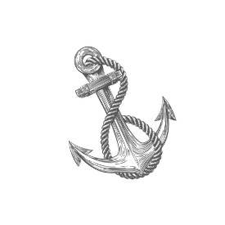
ANCHOR COUNSELING & WELLNESS, LLC
anchorcounselingwellness@gmail.com
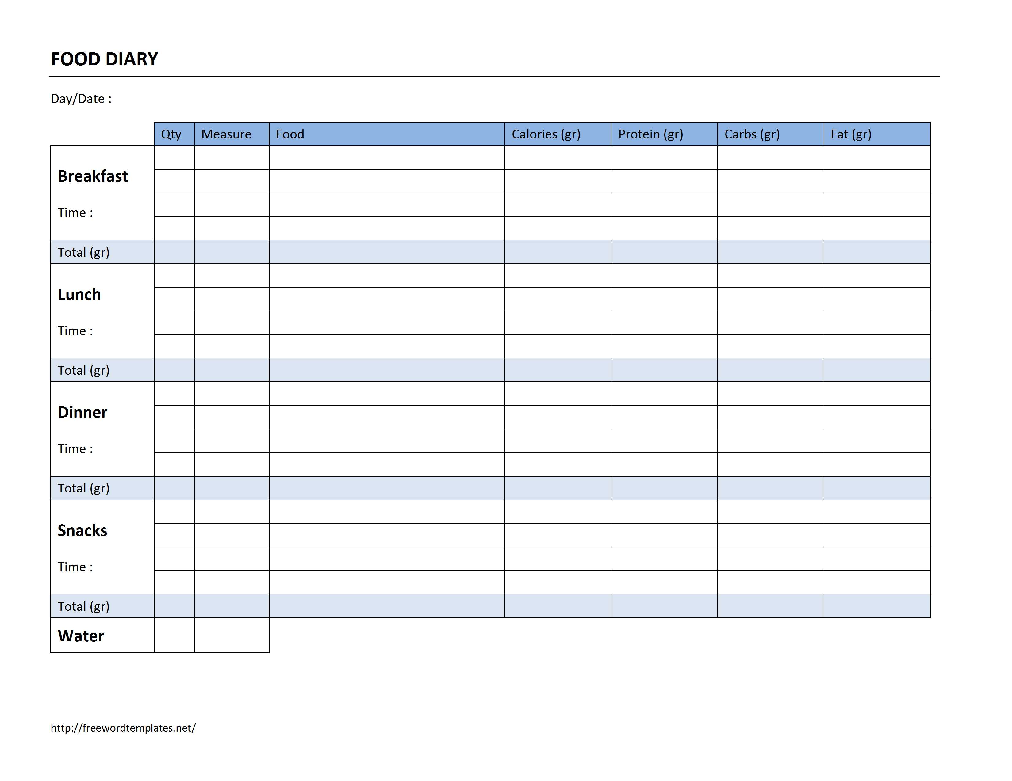
anchorcounselingwellness.com

