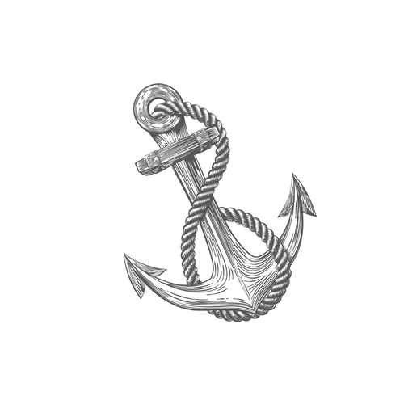
ANCHOR COUNSELING & WELLNESS, LLC
Rebecca G. Cowan, PhD, LPC, NCC, DCC
anchorcounselingwellness@gmail.com
anchorcounselingwellness.com
_________________________________________________________________________

PRIVACY MEASURES

It is recommended that you use the same safety measures that I use for keeping your information confidential.

When receiving distance counseling it is also recommended that you:
- Conduct the sessions in a private location where others cannot hear you.
- Do not keep your therapists contact information on your phone if it is synced with other accounts/applications.
- Do not record any sessions.
- Password protect your computer, tablet, phone, and any other device with a password that is unique.
- Use full disk encryption on any computer and/or device you use.
- Always log out of your sessions.
- Do not have any software remember your password. Sign in every time.
- Do not share your passwords with anyone.
- Do not share your computer when you are logon to any counseling software.
- If you wish to avoid others knowing that you are receiving counseling services, clear your browser’s cache (browsing history), and on your phone, list your therapist by a name rather than as “counselor or therapist”.
- Do not download or store information off of your client portal. However, if you do decide to, only store in on an encrypted file.
- Have all of your devices set to time out requiring you to sign back in after a set idle time.
- Keep your computer updated.
- Use a firewall and antivirus program.
- Router / Access Point
  - Only use a secure network for internet access using a WAP2 security key.
  - Use your own administer ID and password (not the default) for your router or access point.
  - Choose a custom SSID name, not the default name.
  - Limit the range of you Wi-Fi by positioning it near the center of your home.
- Notify your counselor if you suspect any breach in your security.
- For more information on securing your mobile device visit: http://www.healthit.gov/providers-professionals/how-can-you-protect-and-secure-health-information-when-using-mobile-device

